Git Assignment

Question 1:

1. Create a git repository.

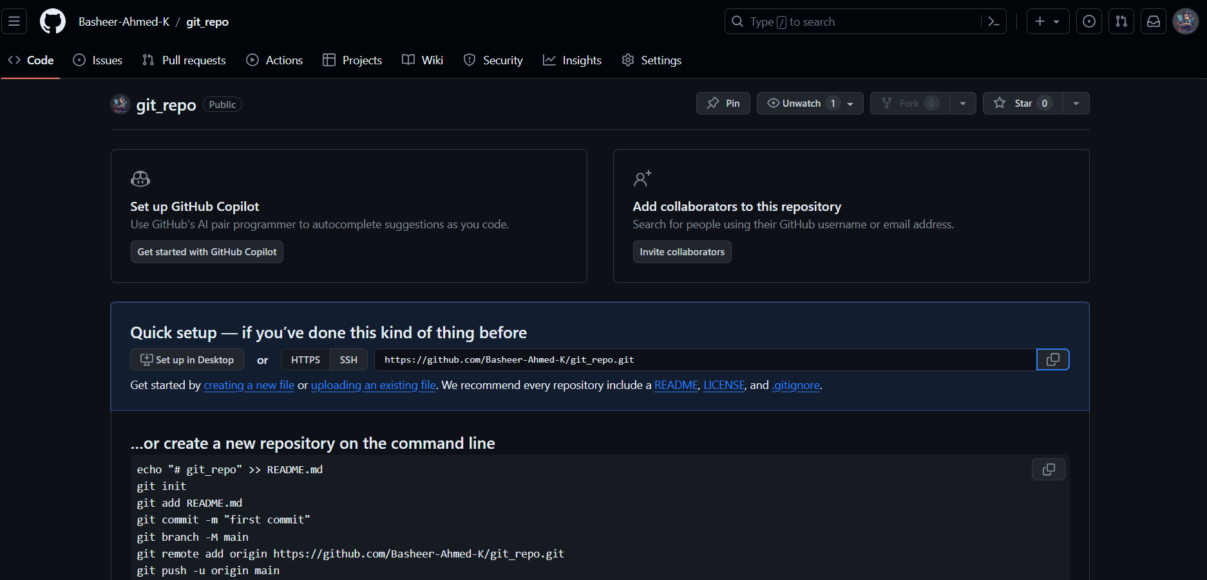

1. Create a file and commit changes.

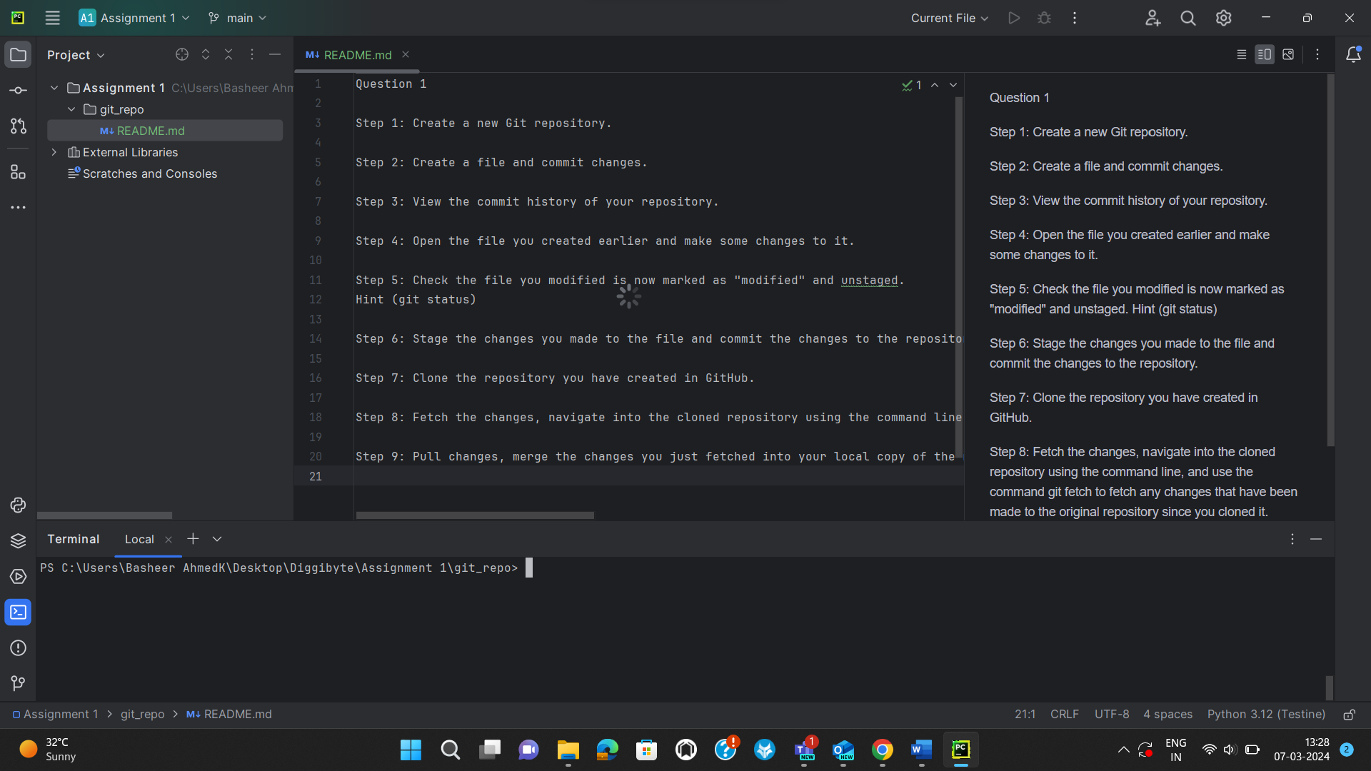

1. View the commit history of your repository.



1. Open the file you created earlier and make some changes to it.

I have made some changes in the README.md file.

1. Check the file you modified is now marked as "modified" and unstaged. Hint (git status)

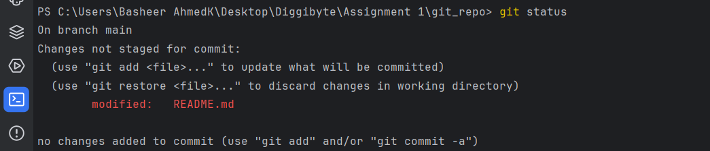

1. Stage the changes you made to the file and commit the changes to the repository.

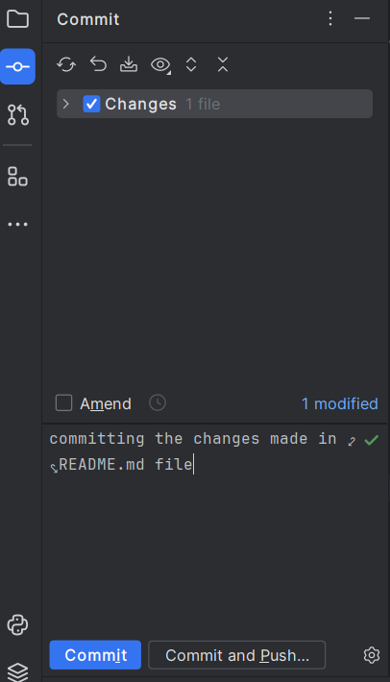

1. Clone the repository you have created in GitHub.

1. Fetch the changes, navigate into the cloned repository using the command line, and use the command git fetch to fetch any changes that have been made to the original repository since you cloned it.

The Changes made in the main repo will not reflect in to cloned repo, So if you want to be update your cloned repo you can do it in many ways one way

**(one way “git fetch”, “git merge”)**

Step 1: in cloned repo you need to run this command “git fetch”.

This fetch will not reflect the changes in your working directory.

Step 2: If you want you update you cloned repo you need to run this

command “git merge”.

Now it will reflect the changes in your cloned repo.

The cloned repo is now Updated.

Main Repo:

Cloned Repo:

Merge:

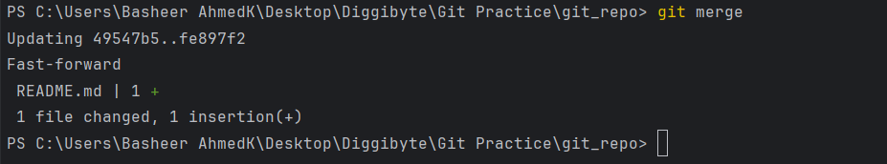

**(Other way “git pull”)**

This command is will directly update your cloned repo with Latest Repo

